**Data disk size Increased on azure**

**Step1:** First of stop this instance from portal.  
  
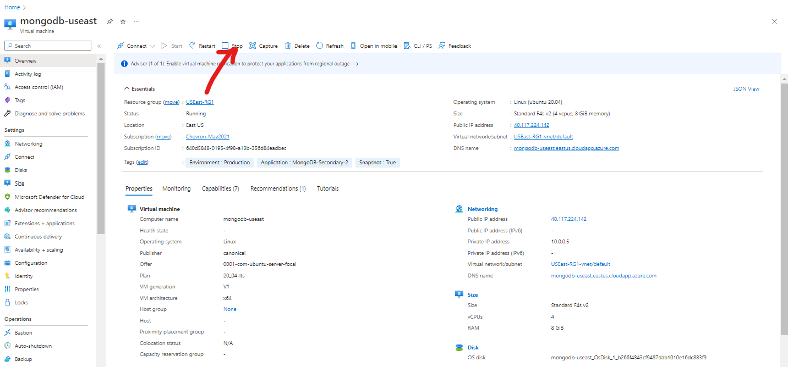

Step 2: click on **Disk** and select disk which you wants to resize.

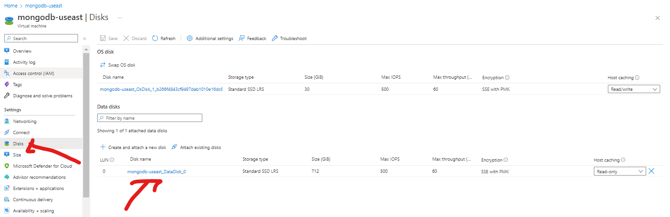

Step 3: click on **Size + perfomance** and then enter **custom disk size** or you can select on existing list.

Once you enter custom disk size click on **Resize** and wait to disk space resize successfully.  
 And then **start the VM.**

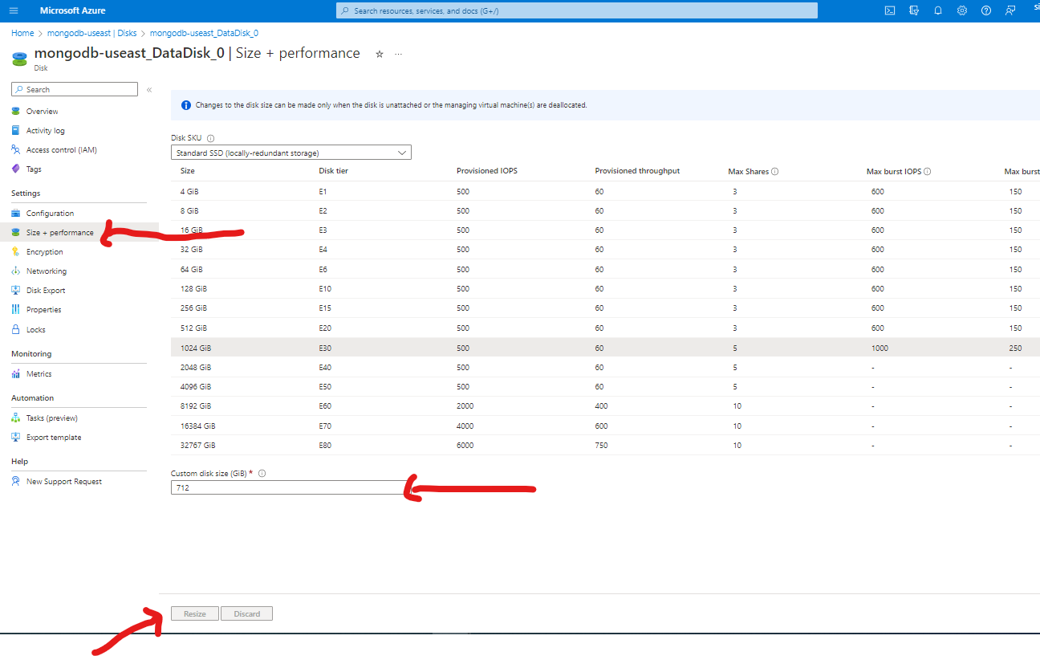

**Steps4:** After the resizing disk from portal login with putty and needs to configure disk

Login to Your Linux VM and check how many disks You have used and how much space You have:

**$ df -h**

It’s still showing the old size as it is

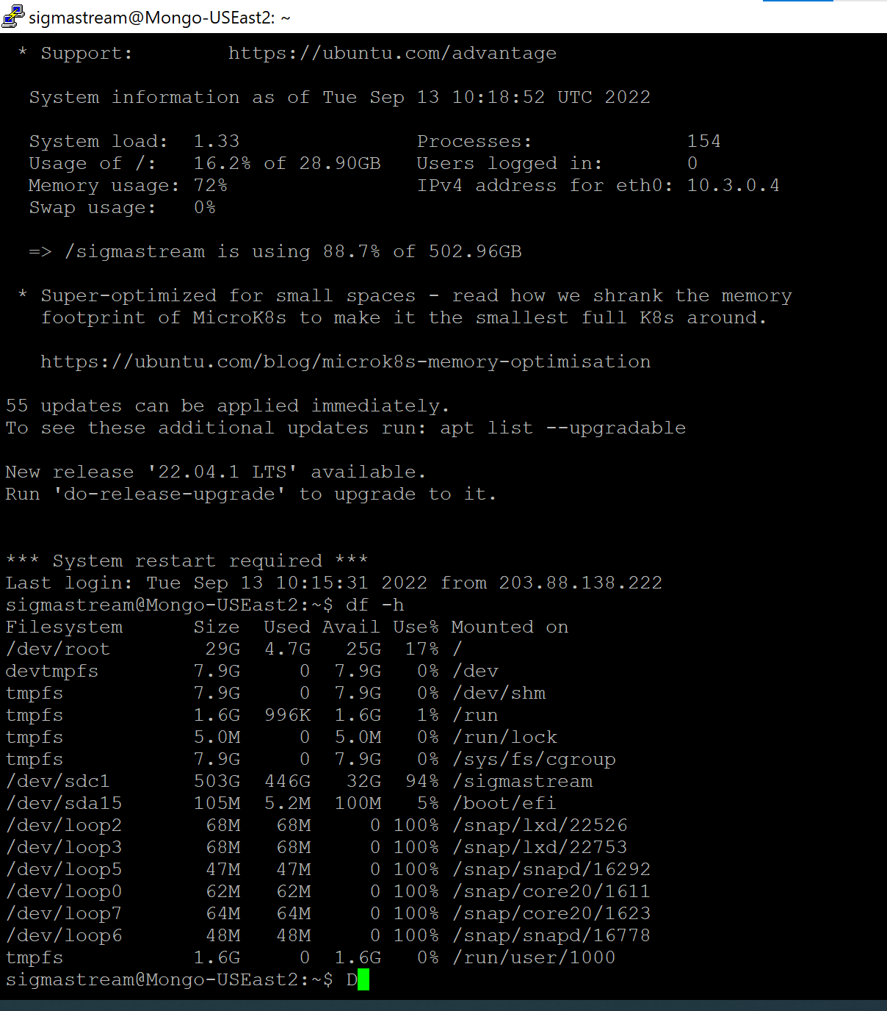

**Steps5 :** When you check with **$lsblk** its showing you your /dev/sda size showing 700G but in the /dev/sda1 its still seen old one so need to run **fdsik** comand and configure it.

**$ sudo fdisk /dev/sda** (set according data disk )

**Steps6 :** Press**p** to list the partitions details. The most important information is the starting sector (e.g. 2048).

**Steps 7 :** Next step is to delete the partition (it will not delete Your data, it will only alter the partition table).  
**Press d**and select the partition (if it’s only one partition, it will be selected automatically).

**Steps8 :** Now we are going to create a new partition. **Press n** and next **press p** to create a primary partition.  
Press **1 or 2** to create first or second partition (depends on which partition we deleted). Next, enter the same value for starting sector from step where we have been printing an informations about partitions. To end accept the default end sector to use the entire disk.

1

Enter

Enter

Press Y

Steps 9: Write the partitions **pressing w.** If there will be some error, just ignore it - it's OK.

**Stesp 10** : Resize the filesystem

$ sudo resize2fs /dev/sda1 (Select here resize partitions.)

Now verify with **$ df -h**